

**An Analysis of Retail Trends**

|  |
| --- |
| **Skills Acquired** |

* Data Cleaning
* Sorting, filtering, and visualizing sales data
* Identifying top-performing products/customers/regions
* Simple trend analysis
* Creating a story from numbers

|  |
| --- |
| **Dataset** |

Acquired from Kaggle, Superstore Sales Dataset by Rohit Sahoo.

|  |
| --- |
| **Links** |

* Kaggle Dataset: <https://www.kaggle.com/datasets/rohitsahoo/sales-forecasting>
* My GitHub Page: <https://github.com/ananyalytics/Business-Analytics>
* Kaggle Profile: <https://www.kaggle.com/ananyalytics>

Uncovering Sales Insights:

An Analysis of Retail Trends

Overview

This project aims to explore and analyze sales data to uncover meaningful insights that can drive strategic business actions. By examining historical sales trends, identifying top-performer products or regions, and detecting seasonal or behavioral patterns, the analysis will highlight both strengths to capitalize on and weakness to improve.

Using basic analysis techniques–such as trend analysis and visualization–the main goal of this project is to convert raw sales data into clear, actionable intelligence. The goal is not just to report what happened but to understand why it happened and what can be done about it.

Ultimately, this project serves as a foundational example of how even simple analytical tools, when applied thoughtfully, can reveal deep value in business data – guiding smarter decisions without requiring complex algorithms.

Project Objective

Derive actionable insights for business stakeholders by analyzing sales data to identify:

1. Key patterns
2. Top performers
3. Growth opportunities

Stakeholders Involved

1. Business Executives
2. Sales Managers / Sales Team
3. Marketing Team
4. Inventory and Operations Managers
5. Business Analysts / Data Analysts
6. Retail Store Managers
7. Investors or Financial Planners

Data Insights

1. Sales Revenue is Growing, What About the Profits?

* We’re selling more units, but is the profit able to catchup?
* Data analysis indicates that while sales revenue has consistently increased quarter-over-quarter, profits have also shown a proportional rise. This suggests that the business is not only scaling sales but doing so efficiently, maintaining a sustainable profit margin.

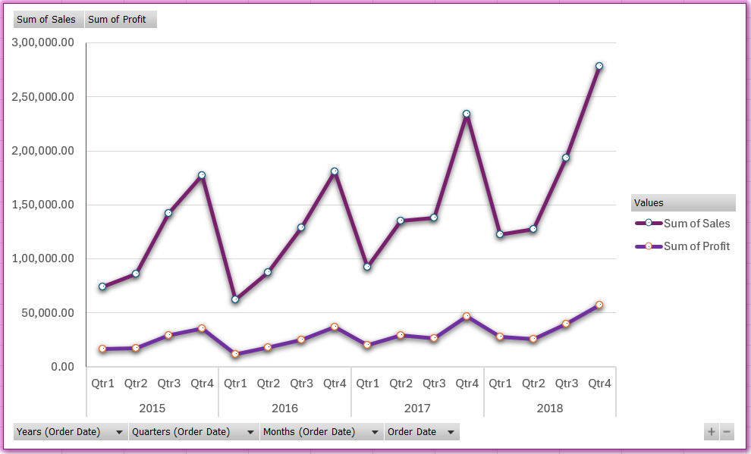

1. Inventory and Supply Strain on Bestsellers

* Some products give more profit than the others. Are we prioritizing the right ones?
* Comparing the top 10 products by sales volume and by profit shows only 6 overlaps. This suggests 4 highly profitable products aren’t selling as much as they could.

**Recommendation**: Prioritize marketing and inventory support for these 4 under-leveraged, high-margin items to optimize profit without necessarily increasing volume.

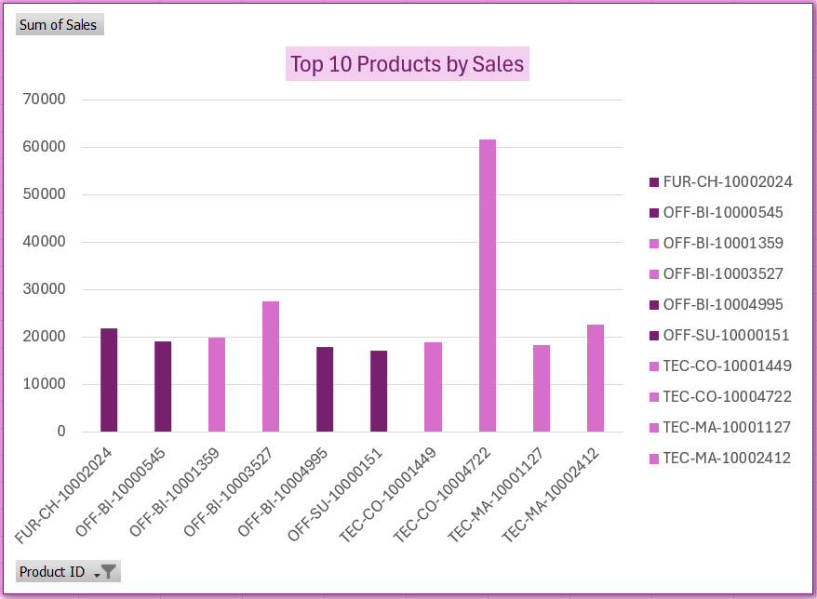

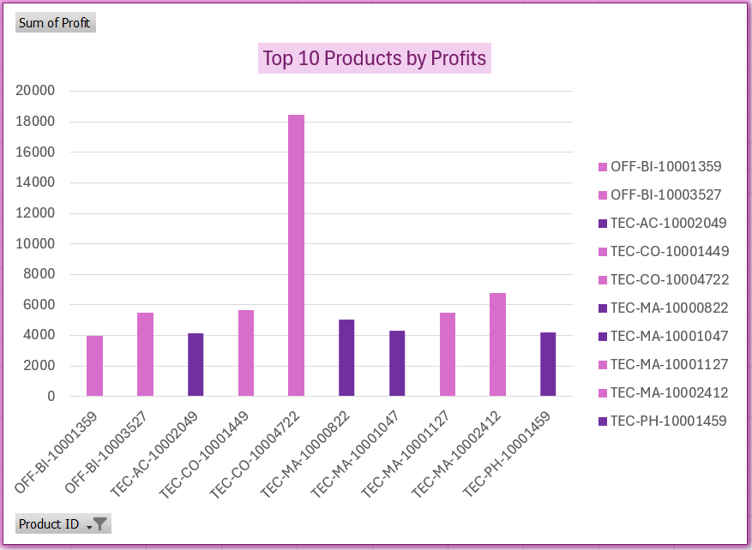

**Root Cause Analysis**

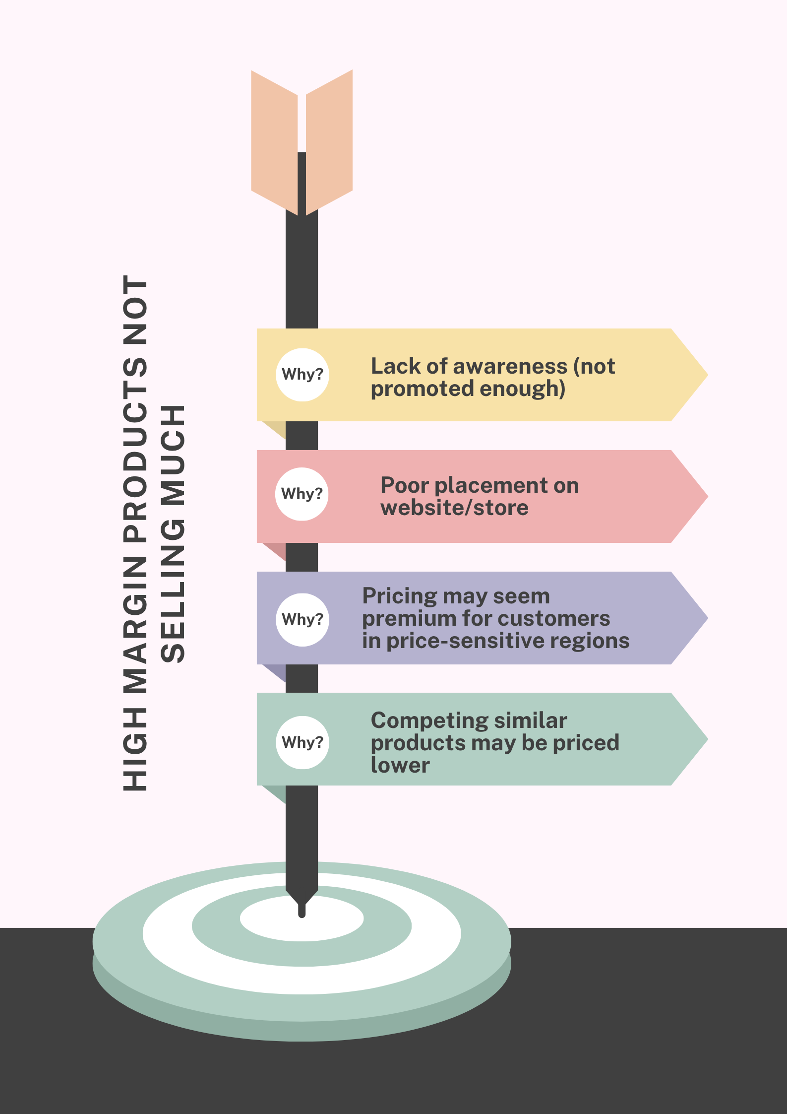

1. Region-Level Sales Imbalance

* Some regions consistently underperform. Should we shift our focus?
* The East (29.60%) and West (31.40%) regions significantly outperform Central (21.78%) and South (17.21%) in sales contribution. Over 60% of total sales come from just two regions, suggesting potential untapped market opportunities in Central and South.

**Recommendation**: Investigate regional demand patterns, marketing efforts, and distribution gaps in underperforming zones to drive balanced growth.

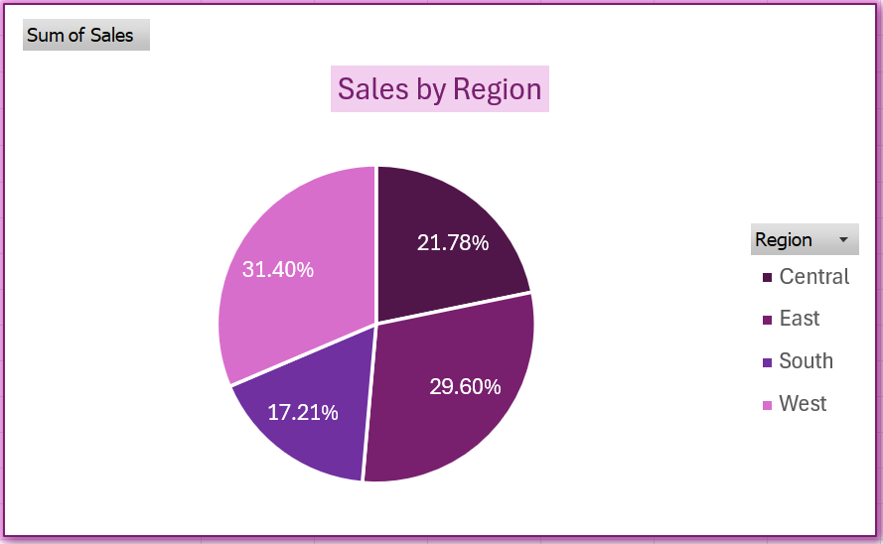

**Root Cause Analysis**

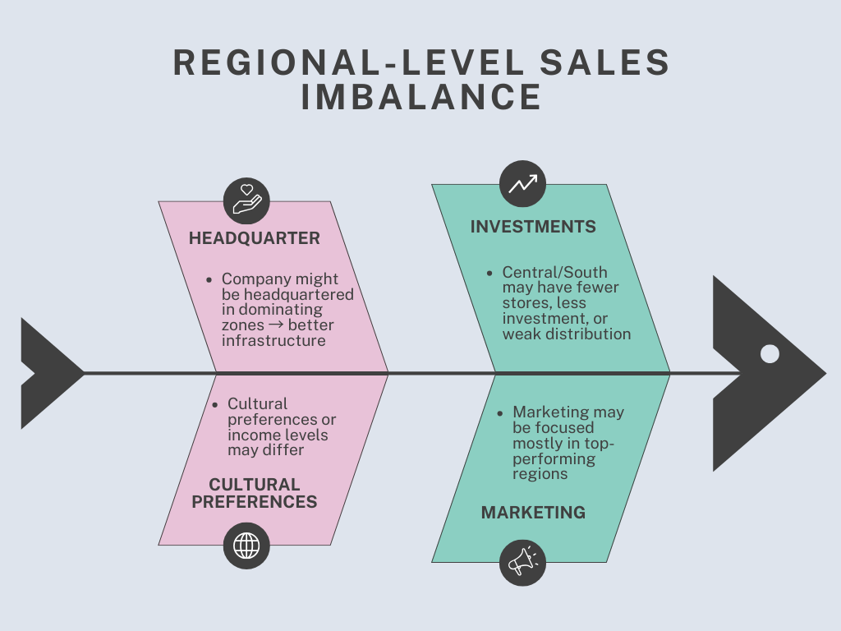

1. Visibility into Seasonal Trends

* We’re not sure when sales usually spike. Planning is hard.
* Sales consistently spike in Q3 and Q4 compared to Q1 and Q2, revealing a clear seasonal pattern. These late-year surges likely align with holiday demand, promotions, or market cycles.

**Recommendation:** Align inventory, marketing, and staffing strategies to capitalize on Q3–Q4 peaks, and explore ways to stimulate demand in slower quarters for steadier revenue shall be beneficial.

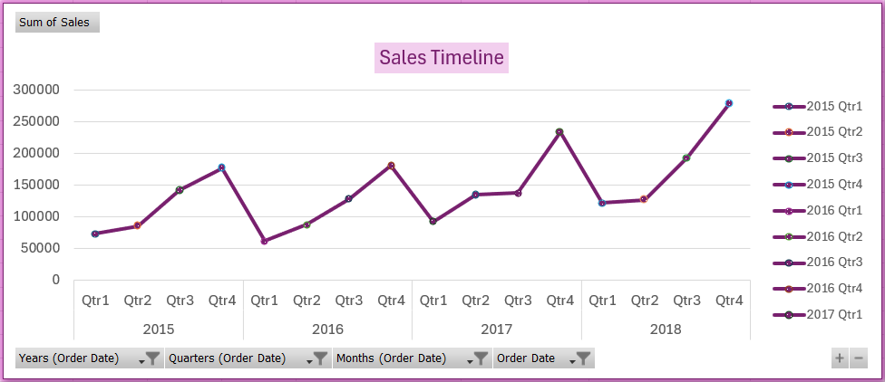

**Root Cause Analysis**

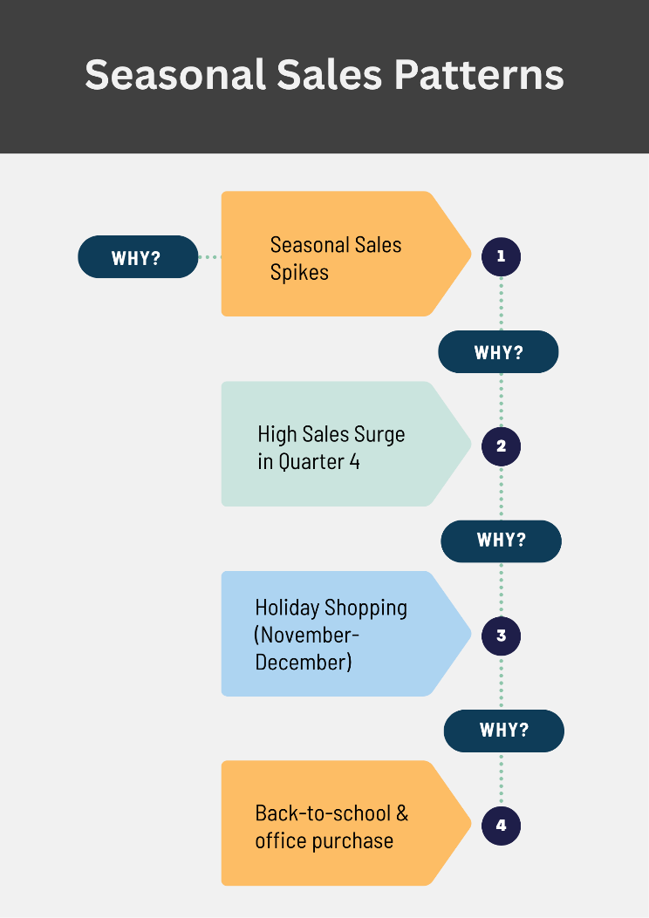

1. We Don’t Know Our Top Performers

* We’re not tracking our most valuable products or categories.
* Phones (14.49%), chairs (14.27%), storage (9.70%), tables (8.97%) and binders (8.84%) lead in sales across product categories. These top 5 products contribute a significant portion of total sales–yet without consistent tracking, we risk missing optimization opportunities.

**Recommendation**: Implement a product performance dashboard to monitor sales and profitability trends in real-time, enabling smarter pricing, inventory, and marketing decisions.

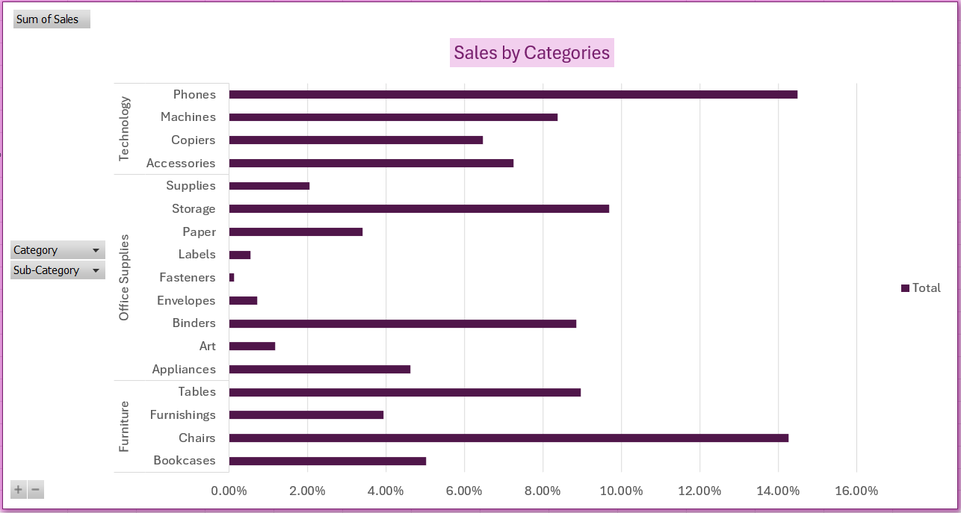

**Root Cause Analysis**

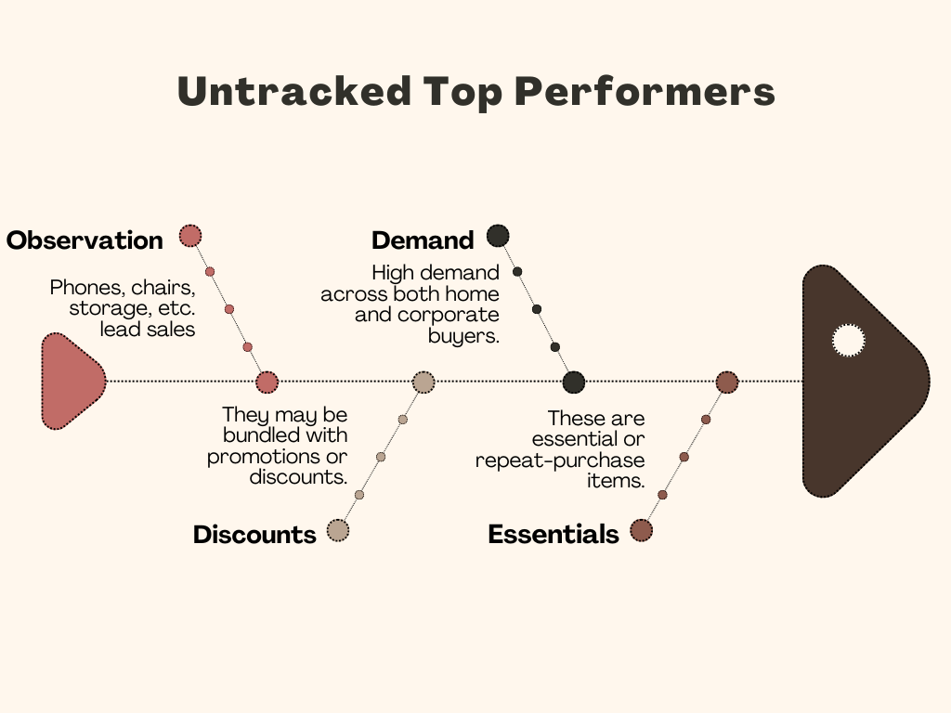

1. Forecasting Readiness

* We want to use this data to forecast next quarter. What patterns exist?
* Historical data shows a consistent dip in sales during Q1 and Q2, followed by a strong surge in Q3 and Q4. This reoccurring pattern suggests seasonality, likely driven by consumer behavior or market cycles.

**Recommendation**: Build seasonal forecasting models that emphasize Q3–Q4 performance. In Q1–Q2, focus on cost optimization, inventory control, demand generation to mitigate slow periods. Prepare for Q3–Q4 surges by scaling marketing, staffing, and supply chain readiness ahead of time.

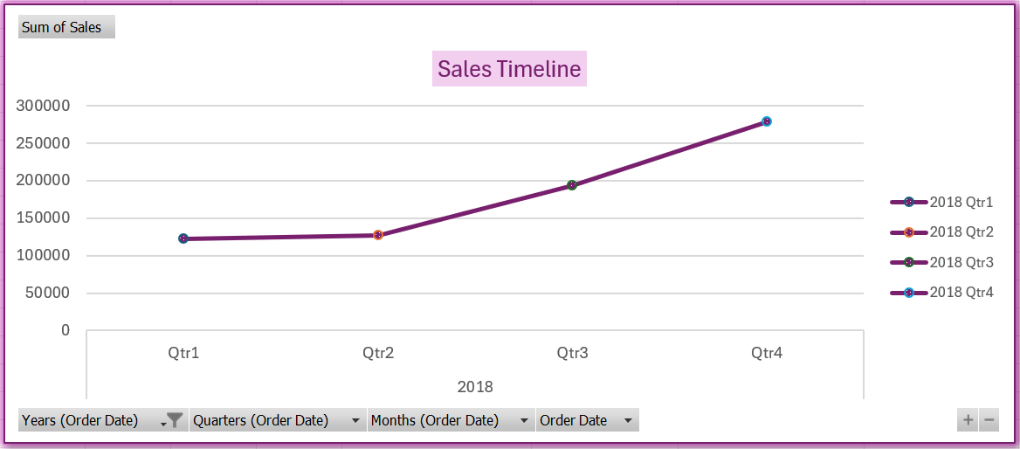

Key Findings

1. Sales are rising with profits, showing efficient scaling.
2. Some high-margin products are not prioritized – a lost opportunity.
3. East and West dominate sales; Central and South are untapped.
4. Sales spike in Q3-Q4 – planning must align with this.

Consolidated Recommendations Table

|  |  |
| --- | --- |
| Insight Area | Recommendation Summary |
| High-margin products | Boost visibility through marketing and stock prioritization |
| Regional imbalance | Explore growth strategies for Central and Southern regions |
| Seasonal patterns | Prepare staffing and inventory ahead of Q3/Q4; promote Q1/Q2 campaigns |
| Forecasting readiness | Build a seasonal demand model with rolling quarterly inputs |

Limitations and Assumptions

* Profit was estimated using assumed category-level margins.
* The analysis does not consider competitor actions or market disruptions.
* Data comes from a historical snapshot – future conditions may differ.

Closing Statement

This project demonstrates how structured, non-coding analysis using sales data can drive informed decision-making across marketing, operations, and strategy. With the right focus, even simple spreadsheets can uncover powerful business opportunities.

Reflection

Completing the project marked a major turning point in my journey as an aspiring Business Analyst. Unlike my earlier projects, which were survey-driven and involved simpler data, this was my first real-world data set with depth, scale, and business complexity.

I learned how to:

* Navigate a large dataset with nearly 10,000 columns,
* Use Pivot Tables and visual tools in Excel to generate insights,
* Estimate profit using logical assumptions,
* And most importantly, connect data patterns to actual business problems faced by retail companies.

What I gained:

* A solid understanding of retail sales dynamics,
* Confidence in using Excel as an analytical tool, not just a calculator,
* The ability to turn insights into stakeholder-specific recommendations,
* And a deeper appreciation for root cause thinking – moving beyond “what” into “why”.

This project gave me a clear sense of what Business Analysts really do: not just analyze, but influence decisions. I’m excited to keep building on this foundation in future projects – bringing even more depth, creativity, and business relevance into every analysis I do.